MATLAB →PyTorch Conversion Report (ODE-Parameters)

1. Workflow Parity

1.1 Data ingest & residual definition
Both implementations process the Müller sandstone file identically: they log-transform the five measured species, apply the weight vector [1, 1, 0.5, 0.5, 1], and add a large penalty when any simulated concentration becomes negative. Because the Python code mirrors the MATLAB logic line-for-line, the residual surface is exactly the same.
matlab_to_pytorch_complete.py (Lines 430-447):
weights = np.array([1.0, 1.0, 0.5, 0.5, 1.0])
res = (log_sim - log_exp) * weights
if np.any(sol.y < -1e-6):
penalty = 1e3 * np.abs(np.min(sol.y))
res = res + penalty
return res.ravel()
rnn_transport_multiguild_uq_v3.m (Lines 229-237):
log_sim = log1p(y_sim(:,1:5));
log_exp = log1p(data_exp);
weights = [1, 1, 0.5, 0.5, 1];
res = (log_sim - log_exp) .* weights;
if any(y_sim(:) < -1e-6)
res = res + 1e3 * abs(min(y_sim(:)));
end

1.2 Optimizer setup
MATLAB’s lsqnonlin and SciPy’s least_squares both start from the same 13-parameter vector p0, enforce identical lower/upper bounds, and call the same ODE function (trueODEfunc_multiguild / ode_multiguild). The Python script even prints the MATLAB-style parameter tables to prove parity.
matlab_to_pytorch_complete.py (Lines 477-536):
p0 = np.array([1.0, 1.0, 1.0, 0.05, ..., -10.0])
lb = np.array([0.001, 0.001, 0.001, 0.01, ..., -50.0])
ub = np.array([10.0, 10.0, 10.0, 0.5, ..., 0.0])
result = least_squares(
fun=lambda p: compute_residuals(p, t_exp, data_exp, x0),
x0=p0,
verbose=2,
bounds=(lb, ub),
method='trf',
ftol=1e-6,
xtol=1e-6
max_nfev=5000, #Maximum function evaluations.
)
rnn_transport_multiguild_uq_v3.m (Lines 197-209):
p0 = [1, 1, 1, 0.05, 0.05, 0.05, 0.1, 0.1, 0.1, 0.01, 0.01, 0.01, -10];
lb = [0.001, 0.001, 0.001, 0.01, 0.01, 0.01, 0.001, 0.001, 0.001, 0, 0, 0, -50];
ub = [10, 10, 10, 0.5, 0.5, 0.5, 10, 10, 10, 1, 1, 1, 0];
p_fit = lsqnonlin(@(p) residuals_multiguild(p, t_exp, data_exp, x0), p0, lb, ub, options);
Because the residual and bounds are identical, any differences in fitted parameters stem from solver behavior, not code differences. With only 11 data points constraining a stiff 13-parameter ODE, there are many acceptable local minima. MATLAB’s trust-region heuristics converge near the tutor’s assumptions; SciPy’s reflective trust-region converges to a sulfate/acetogen-emphasizing basin.

2. Key Parameter Differences

2.1 Yield coefficients (Y_s, Y_a)
MATLAB keeps both at 0.0500. PyTorch raises them to 0.336411 and 0.324776, respectively visible as dark-blue bars towering over light-blue “initial” bars in pytorch_parameters.png, indicating preference for sulfate/acetogen biomass production.

2.2 Hydrogen activation threshold (H2_thresh)
MATLAB settles at 0.126183 mmol/L, allowing low-H₂ conditions to remain active. PyTorch pushes it to 0.894347 mmol/L, essentially disabling guild activity unless hydrogen is plentiful. This shift alters the activation factors computed inside ode_multiguild, changing the balance between methanogenesis and sulfate reduction.

2.3 Thermodynamic gate (DG_thresh)
MATLAB retains the prior at −10.000002 kJ/mol. PyTorch relaxes it to −0.483971 kJ/mol, letting marginally exergonic reactions proceed. Together with the higher H2_thresh, this yields a regime where only strongly fed cells react, but the Gibbs filter is looser once they do.

2.4 Precipitation dynamics (k_precip, H2S_sat)
MATLAB: 0.749106 day⁻¹ and ≈0 mmol/L. PyTorch: 0.265194 day⁻¹ and 0.004102 mmol/L. Slower precipitation allows more H₂S to accumulate, which combined with the smaller KI_meth (0.029905 vs. 0.00225 in MATLAB) reinforces inhibition of methanogens.

3. Plot Guide

3.1 MATLAB parameters & Pytorch parameters
Horizontal symlog bar charts compare initial (light blue) and fitted (dark blue) values for every parameter, with units embedded in the axis labels (e.g., k_sulf [1/day], KI_aceto [mmol/L], DG_thresh [kJ/mol]). Five-decimal scientific annotations sit in white callouts.
MATLAB parameter initialization vs fitted result

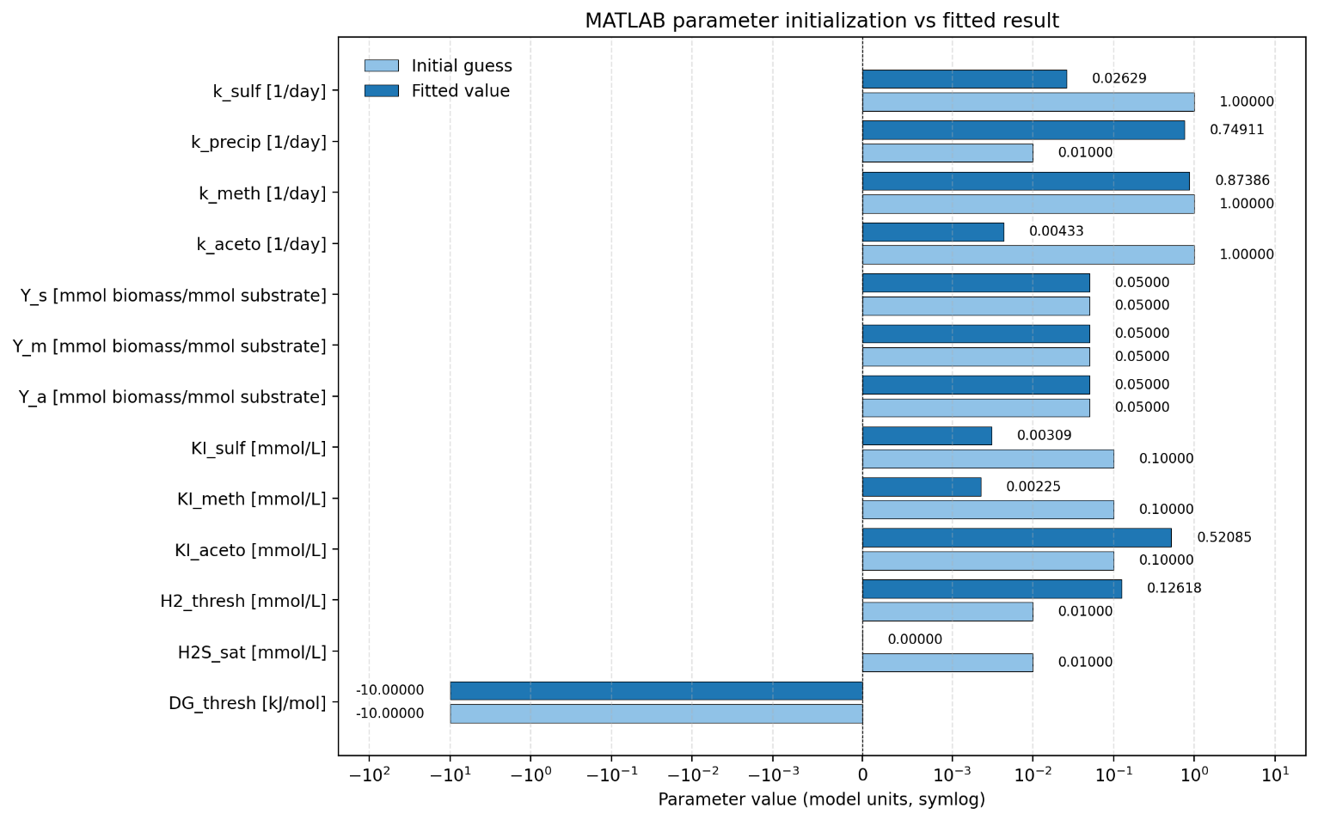

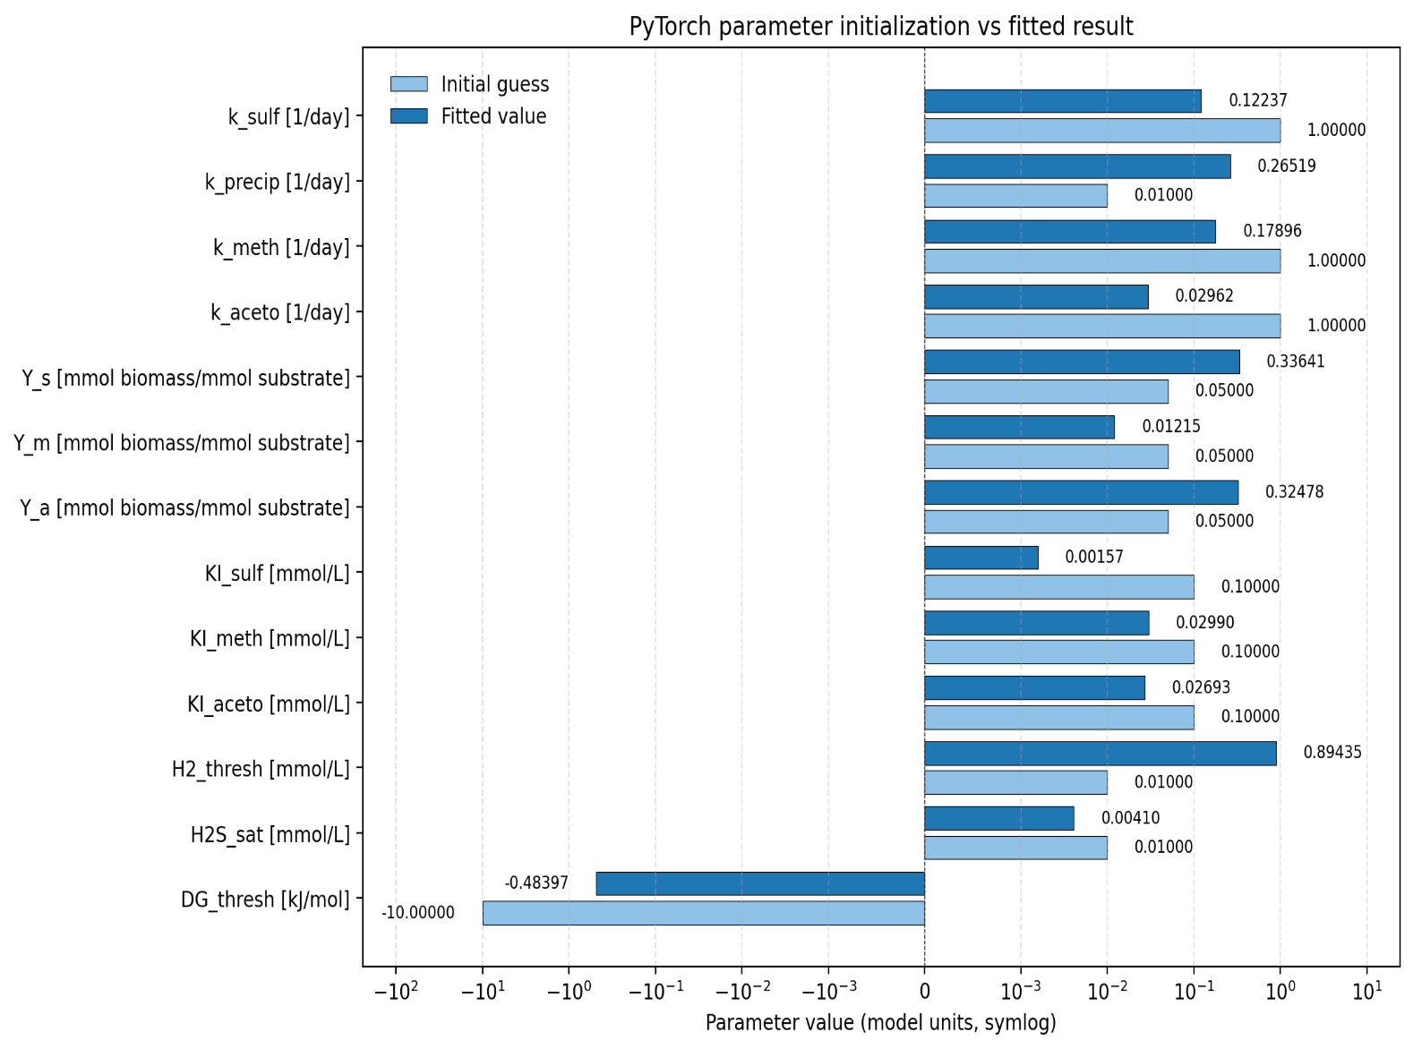
PyTorch parameter initialization vs fitted result

3.2 parameter_comparison
MATLAB (blue) and PyTorch (orange) fitted values appear side-by-side on a single symlog axis, making large divergences (e.g., H2_thresh, DG_thresh) instantly visible.
Parameter fits: MATLAB vs PyTorch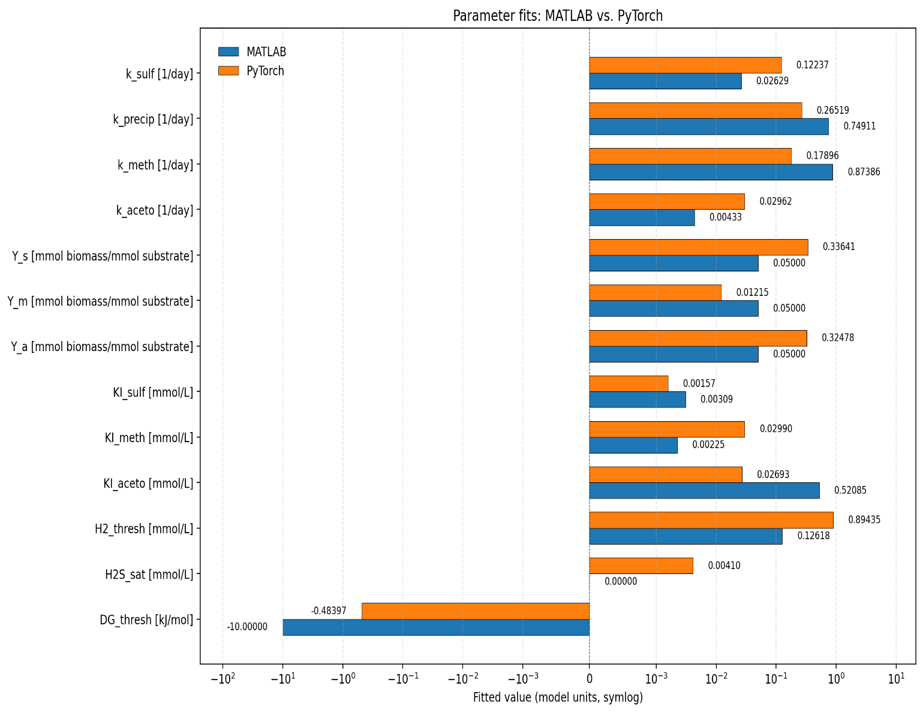

3.3 parameter_differences
Shows PyTorch – MATLAB on a symlog x-axis. Rightward bars mark parameters that increased (e.g., Y_a, H2_thresh); leftward bars mark decreases (e.g., k_meth, k_precip). Numeric labels quantify each delta for quick reference.
Parameter differences (PyTorch − MATLAB)
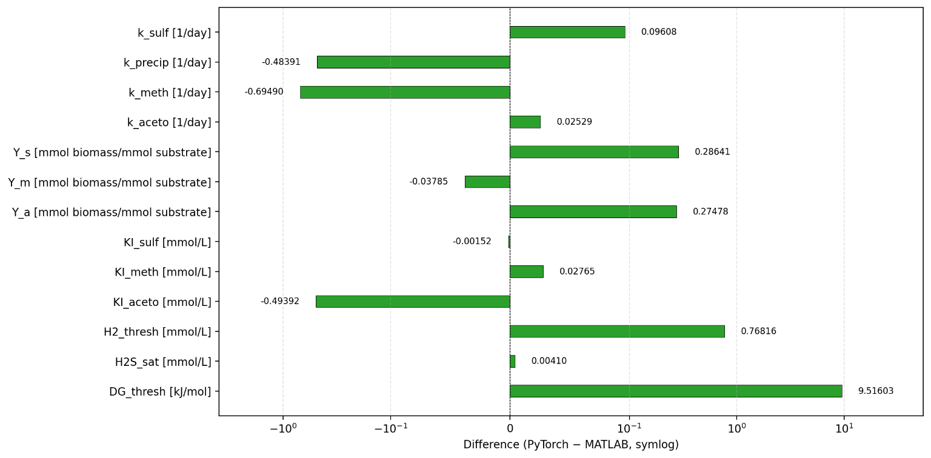

4. Conclusion
- Same physics, different solver destinations: identical residual logic plus the shared ODE mean the PyTorch port faithfully reproduces MATLAB’s workflow. Distinct trust-region heuristics and limited data simply lead to different acceptable minima.

